

Hotel booking form
NAME AND SURNAME
TAX ID CODE
COMPANION’S NAME ACCOMPAGNATOREAAAAAAAAAACCOMPAGNATORE
ADDRESS
CITY
PHONE NUMBER DFFFPHONPHOMN |  | EMAIL
CLUB MEMBERSHIP
DISTRICT |  | LIONS TITLE
ARRIVAL DATE |  | DEPARTURE DATE
OWN TRANSPORT | SI NO
SELECTED HOTEL | SECOND CHOICE
ACCOMODATION | SINGLE TWIN DOUBLE
SPECIAL NEEDS

Hotel reservation forms (together with a photocopy of ID) must be sent no later than 28 FEBRUARY 2025 by email to: segreteriacongressoosimo2025@gmail.com
*After this date, due to the period with many holidays, hotel availability may not be guaranteed
Confirmation of the room will take place after receipt of the payment, which must be made to the following bank account:
RAFFAELLO TRAVEL GROUP (hospitality partner of the event)
IBAN: IT18W0870068701000000082281
METAURO COOPERATIVE CREDIT BANK
reason for payment: Osimo Lions Congress 2025
INFO POINT - XXI CONGRESS OF THE INTERNATIONAL FOUNDATION OF WALLED CITIES LIONS CLUBS
Raffaello Travel Group
Michela Tel: + 39 0722 327831
Mail: segreteriacongressoosimo2025@gmail.com---- website: www.lionscittamurate.com
Date_____________________ ____________Signature________________________________________
*I authorize the processing of personal data pursuant to art. 13 of Legislative Decree 30 June 2003, n. 196 “Personal Data Protection Code” and art. 13 of the GDPR (EU Regulation 2016/679).

HOSPITALITY HOTEL

All proposals include: 2 overnight stays with B&B treatment. Management of booking procedures, info point, 24-hour on-site assistance service.

AFFILIATED HOTEL FOR THE CONGRESS:

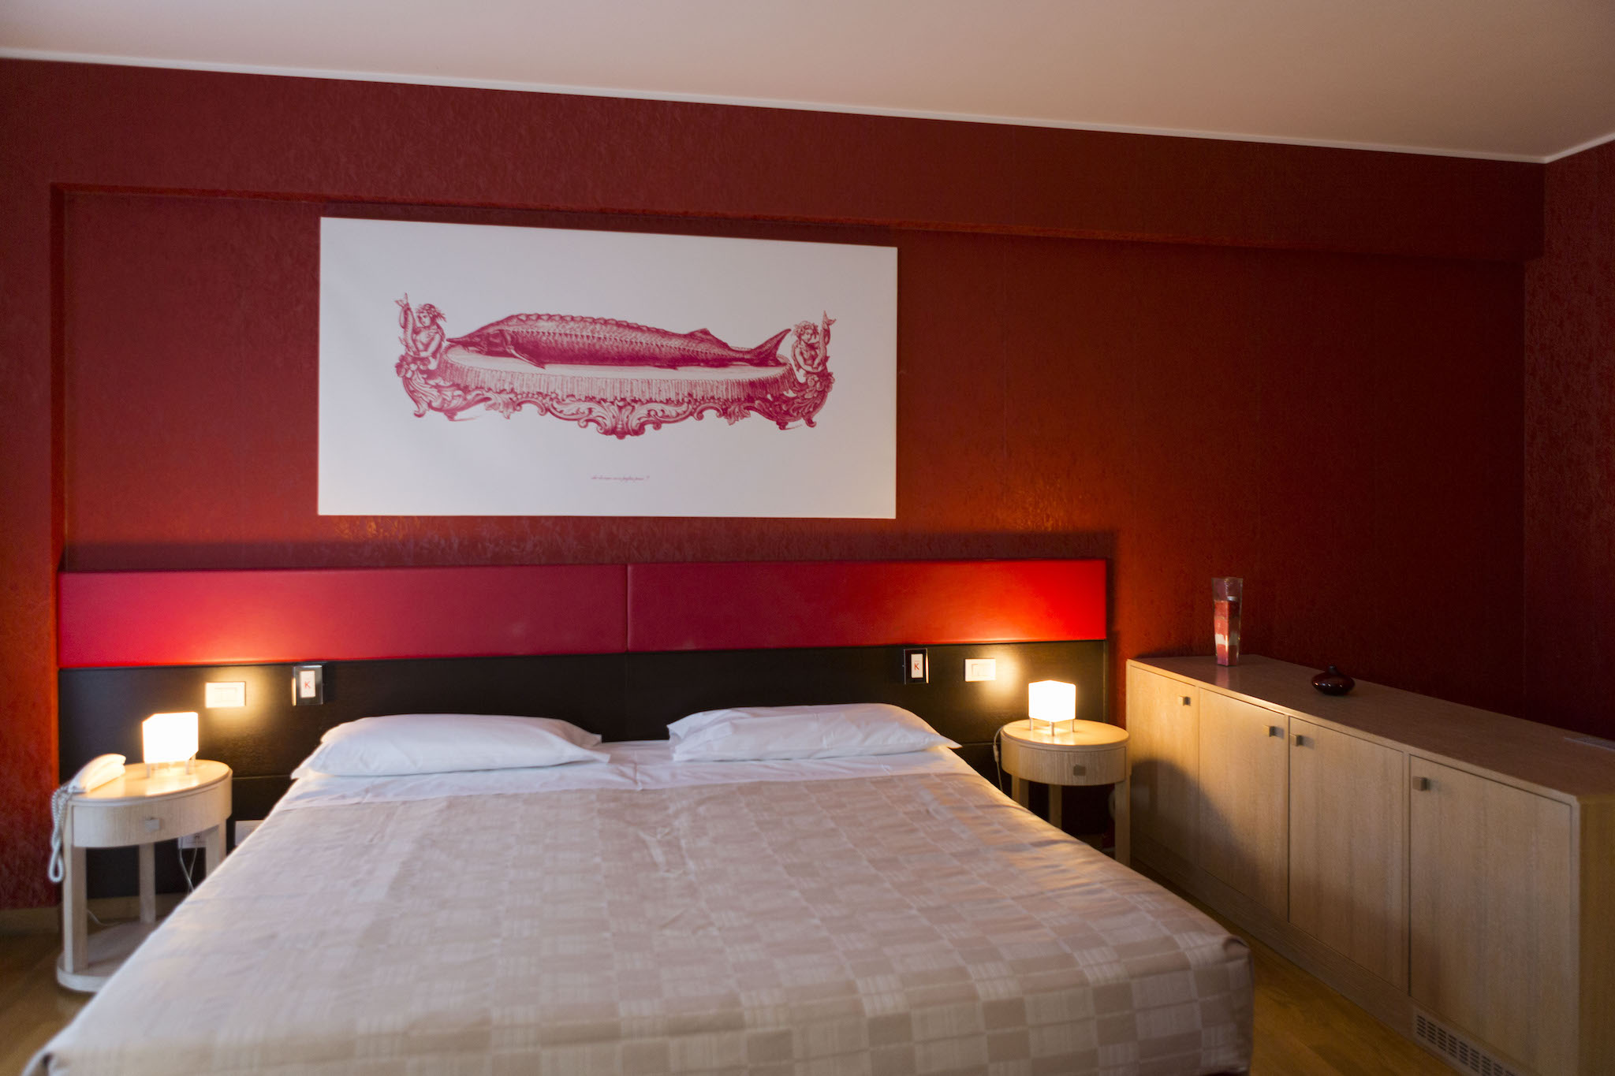 | KLASS HOTEL 4****  Twin/double room: € 238  Double for single use room: € 188  The Klass hotel is located in the heart of the beautiful and welcoming Marche region a few km from Osimo and the main places of interest. Comfortable rooms, equipped with every comfort with wi-fi connection.

HOTELS WITH AVAILABILITY ON REQUEST ONLY

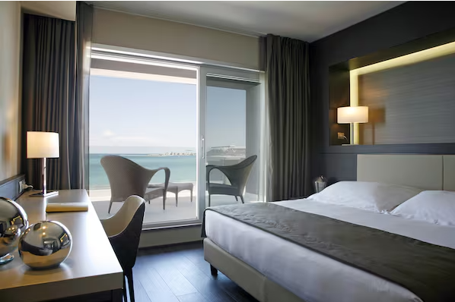 | HOTEL CONCORDE 4****  Twin/double standard room: € 218  Double standard for single use room: € 158  Twin/double superior room : € 238  Double superior for single use room: € 178  Hotel Concorde is strategically located a few kilometres from Osimo. Recently renovated, it includes a gym and fitness centre and offers business-style accommodation with spacious and modern rooms.
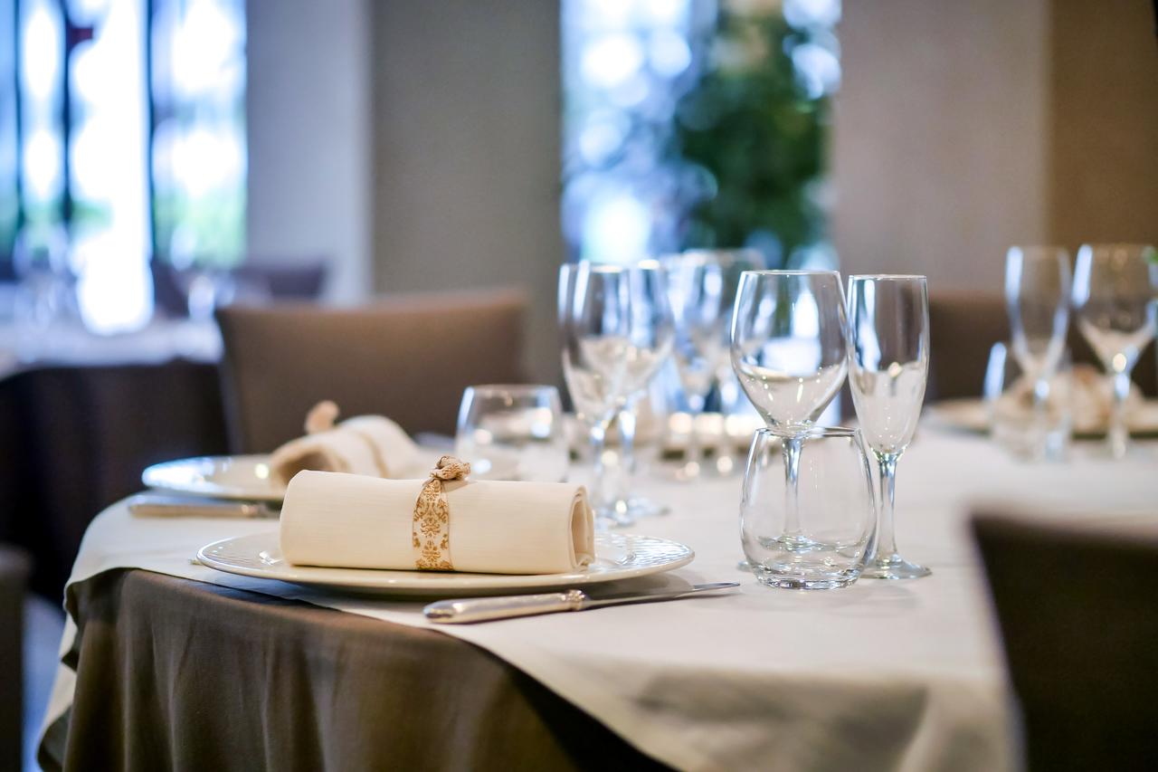
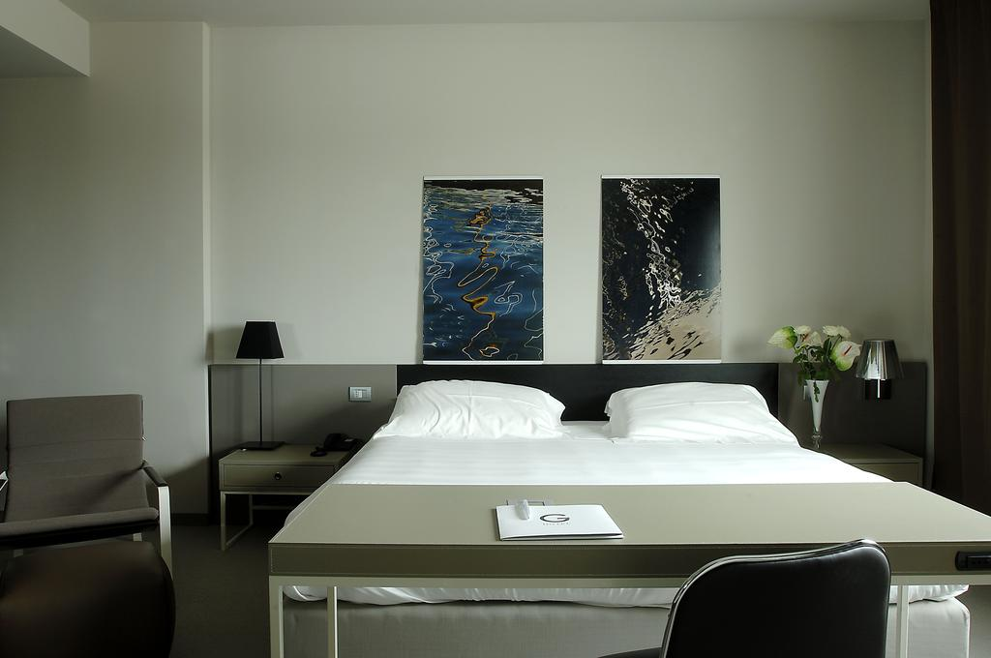 | G HOTEL 4****  Twin/double room: € 288  Double for single use room: € 188  Modern hotel, 5 km from the Monte Conero Regional Park and just a few km from Osimo, offering rooms with flat-screen satellite TV, spacious beds, modern furnishings and minibar.
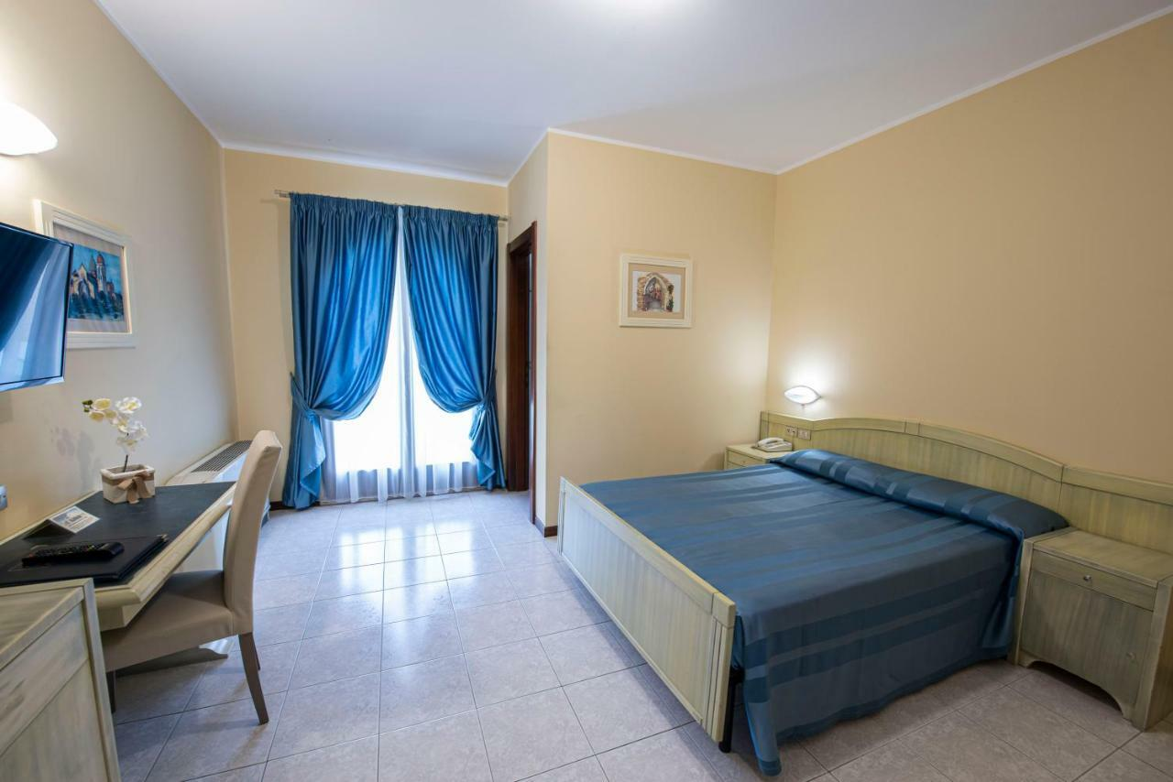 | HOTEL CRISTOFORO COLOMBO 4****  Double room/twin French bed: € 218  Double room fors single use French bed: € 178  Hotel Cristoforo Colombo is just a few km from Osimo and 10 minutes from the Conero Riviera.Business hotel with free Wi-fi in all rooms and common areas and ample parking available for guests..

